**BIEN 235 2019S HOMEWORK 3**

Due by 10:00 am on Thursday 4/4/2019 (30 Points)

***Answering questions***. You can find answers in one or more sources: our textbook, PPT slides, and your lesson and lab notes and observations. Note, short answers are preferred. If you work in a group, use your own words and calculations for your homework assignments. Doing this will help you to understand better and to retain what you have learned.

For questions 8-14, refer to PPT entitled “Protein Interactions with Biomaterials and Surface Modifications.”

1. How fast do proteins in the body adsorb to an implanted material? (See slide 10)

In less than 1 second.

1. Name the two major *properties of surfaces* that affect protein adsorption?

Charge and hydrophobicity

1. What are two *properties of proteins* that affect protein adsorption to a surface?

Charge and Stability

1. How do counter ions help facilitate protein adsorption?

Free anions and cations in the body can bind to both surfaces and oppositely charged domains of a protein. These ions fill gaps between the surface and the protein where the charge across would normally be the same, helping the protein to stay on the surface.

1. If you had three types of protein in a solution surrounding a biomaterial, draw an approximate plot of adsorption over time given the following relationships: Concentration of proteins: [A] > [B] > [C]. Affinity of proteins for the surface: C > B > A. What is the name of this effect?

The Vroman effect.

1. List 3 types of biomolecules that can be conjugated (attached) to smart polymers.

* Ligands
* Signal group
* Liphophilic group

1. Based on what you have learned in the past few weeks about the immune system and about protein adsorption, (a) what molecular component of the innate immune system could cause a seemingly inert biomaterial to become a source of inflammation?

Complement System

(b) How could a person’s own proteins (such as proteins normally found in the extracellular fluid) cause an immune reaction to an implanted material?

To help you answer the remaining questions, use Chapter 8 of our textbook (and/or our PPT slides, if noted).

1. What is a functional group (for a polymer)?

A molecule added to a SAM that encourages a desired reaction from the body

1. The reverse of condensation polymerization is called hydrolysis. (Fill in the blank.)
2. What type of bond gives a polymer’s carbon backbone the ability to rotate?

Sigma bonds

1. List 4 polymer strengthening methods.

* Increasing molecular weight
* Promoting Cross-Linking
* Increasing Crystallinity
* Introducing hard particles or fibers

1. What is the common mechanism for all polymer strengthening and hardening methods?

Making it harder for chains to move

1. What is the common mechanism of polymer deformation?
2. Name three types of copolymers. (Ch 8 or PPT slides)
3. Name one example of a polymer in each of these three categories: bioinert, surface bioerodible and biodegradable.

* Bioinert: Silicone
* Surface bioerodible: Polyurethane
* Biodegradable: PGA

1. What is the difference between bioerodible and biodegradable?

1. Write the name of each type of polymer under the following “skeletal structures.”

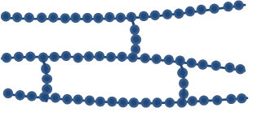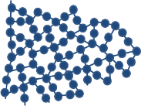

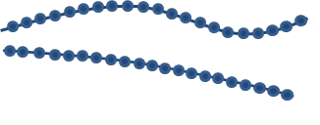

_____Linear________ _______Branched____ ____Cross-Linked____ ____Networked____